## Merchant

Demo date: Early 2024  
Scoping start date: May 1, 2024

MSA Signature Date: Sep 30, 2024  
Onboarding Kick Off Date: Oct 1, 2024

[If Exists] Opt Out Date: 4/1/2025  
Go Live Date: Jan 1, 2025

GTM POC: Rebecca  
Implementation POC: Royce

ERP: Other (Sage)

Tax Integration: QBO Hard Coded Taxes

### 

### Key people at Merchant

* Dave Sheen, CFO
* Brendan Keogh, VP Operational Finance - lead for all billing/operational finance processes
* Eva Oleszczuk, Billing and AR Accountant - hands-on for all billing
* Adriana Morosanu, Senior Billing Manager - junior to Eva
* Ann Bodnar, Senior Billing Specialist - also hands-on with billing items
* Elizabeth Wick, Finance Manager - focused on state reporting process
* Jonathan Ferrara, COO Platform Solutions
* Jade Huynh, Finance Analyst
* Lonny Sternberg, VP Revenue Operations
* Ashley Stone, Revenue Operations Manager
* Jamie Bernardin, AI Advisory Consultant

### 

| Notes Sections [Ops International Team to Ignore] *(AE/ Implementation to fill)* |
| --- |

### 

### Company summary *(AE to fill)*

Vestwell is a fintech company that provides modern retirement planning solutions tailored to small and medium-sized businesses (SMBs), financial advisors, and enterprises. The platform is designed to simplify and modernize workplace retirement plans, such as 401(k) and 403(b) plans, through a fully digital, cloud-based platform.

Goals (North star)  
*(AE/ Implementation to fill)*

Vestwell is transitioning off Ordway. As the business has scaled (5000+ customers; $100mm+ revenue), the cracks in the Ordway platform and process became more pronounced, with the below pain points felt most acutely:

* Their invoicing occurs once per quarter (4x/year) and takes ~5 days, and is extremely painful with lots of overrides and manual upload processes
* Very painful usage CSV imports, because Ordway was not primarily designed for usage
* Slow / delayed support from Ordway offshore team

Our current contract has an opt out after 6 months (April 2025) if we are not able to implement Tabs. Assuming we are, an annual contract will then kick in (and we’ll have an opportunity to revisit commercials if needed).

### Billing model *(AE/ Implementation to fill)*

* Are there unique things about the customer creation process for this merchant?
* Information on how merchant bills
* How contract is broken up
* One off things to know about the merchant

### Contract Processing Steps *(Implementation/Success to fill)*

Steps to process.

1. **Split each customer into 2 sub-customer**
   1. [Customer Name: Sponsor]
   2. [Customer Name: Participant]

Notice in each section of the fee, if it says paid by the Sponsor or Participant. Allocate into the sub-customer section accordingly.

**There’s 4 types of sub-fees:**

1. **One Time Setup Fees**

**This is typically set up as a sponsor fee hence should be included in the sponsor fee portion.**

* 1. Flat Price Billing Type, example language below.

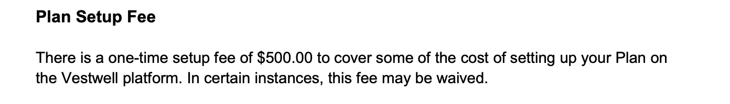

1. **Plan Level Fees** = Flat Price Billing Type, Monthly cadence, 12-period

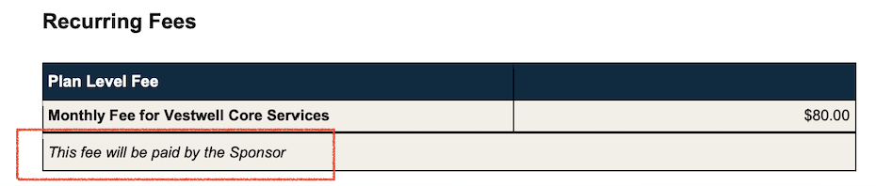

Notice if this says plan or participant.

1. **AUM Fees** =
   * 1. Event Type to use = AUM
     2. Cadence = Quarterly (every 3 months)
     3. AUM fees are listed in the contract. These are annualized amount, meaning that when processing this, it should be divided by 4
     4. Example:
        1. The AUM in the contract below is 0.50%, in this case for processing, divide the number by 12 to monthly rate.
        2. Use 0.04167% as the number to populate for the BT.
        3. beMake sure to check “**Use %**”.

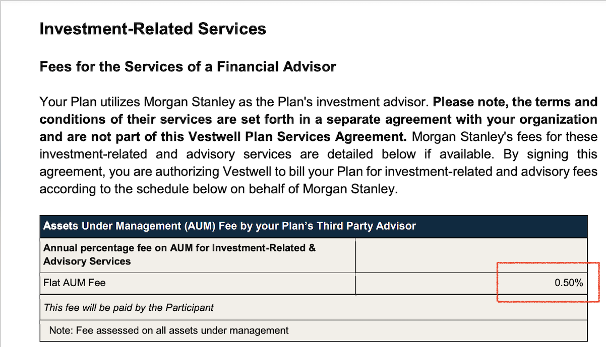

**Billing Term reference in Garage**

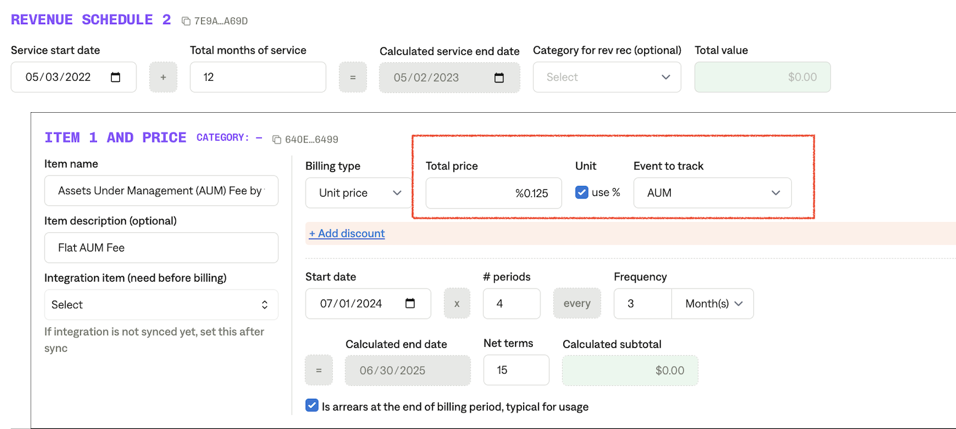

* 1. **Participant Level Fees** =
     1. Either **Unit Price** or **Tier Unit Price**
     2. Event to use “**Participants/Month**”
     3. Example below

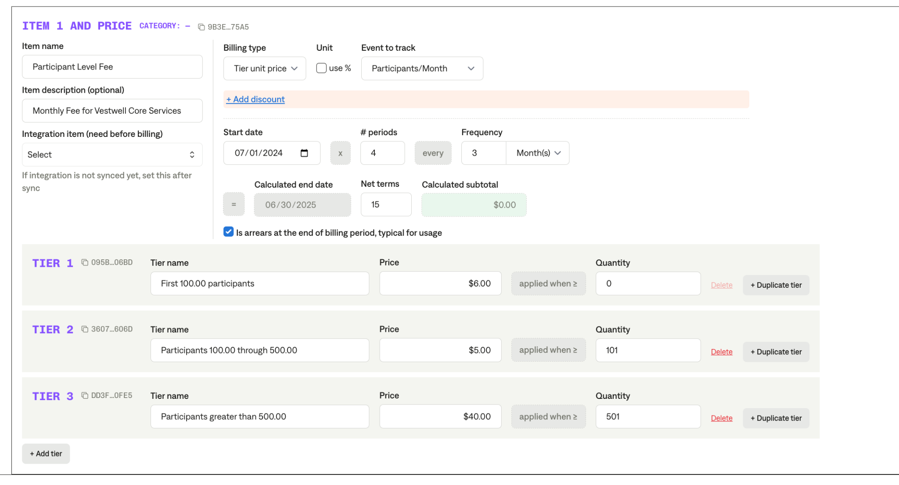

1. Default Service Term
   1. 1 year to start
2. Default Net Payment Terms
   1. If None, Ops Default is **15 (Please make sure this is the default as it’s specifically requested by Vestwell team)**
3. Default Billing Frequency
   1. There’s four types of billing terms for Vestwell
   2. One time setup fee = one time only
   3. Plan Level Fee = **monthly** (note: it’s monthly)
   4. Participant Level Fee = **monthly** (every 3 months)
   5. AUM fees = **monthly** (every 3 months)
4. Invoice Date
   1. Should always be the last day of the quarter
5. How do we handle taxes as a line item?
   1. If None Listed, Ops Default is every tax line item becomes a BT

### Events Processing (if necessary) *(Implementation/Success to fill)*

* Any important information on events billing

Integration Items Processing (if necessary)  
*(Implementation/Success to fill)*

* What are the instructions for assigning integration items?
* Example: All Statsig integrations items should be labeled as “Sales”
* Example: All “Pinata” integration items should be labeled as “Software Subscription Bundle” unless otherwise noted by Merchant

Post Processing Communications (if necessary)  
*(Implementation/Success to fill)*

* Does the Ops Team need to notify anyone on the team re: completion of processing batches in Implementation or Active phase?
* Who needs to be notified and when?
  + Example:
    - Who: Customer Success [Azmat Aziz] needs to be notified
    - Where: Messari internal merchant channel
    - When: contracts are processed [Merchant Phase: Active]

### Customer Information *(Implementation/Success to fill)*

* Any important information on specifics customers of this merchant
  + Special memo’s certain invoices require
  + Invoice changes due to merchant/customer relationship

### Feature Requests *(AE/Implementation/Success to fill)*

* FR 1
  + What is it
  + Why it's important
  + Urgency

### Rewatch Calls *(AE/Implementation/Success to fill)*

* Rewatch by dates